Lab 11: Fine-Tune GPT-4.1-mini in the New Microsoft Foundry
Level: Intermediate · Duration: 2–3 hours, depending on training and deployment time · Training method: Supervised Fine-Tuning (SFT)

Lab objective
In this lab, you will customize a GPT-4.1-mini model to behave like a concise IT help-desk assistant. You will prepare datasets, create and monitor a fine-tuning job, deploy the resulting model, compare its responses with the original model, and perform basic Responsible AI checks.
By the end of the lab, you will have evidence of the completed training job, evaluation results, and model deployment if deployment is available in your Foundry environment.

Prerequisites
- Access to the new Microsoft Foundry
- An Azure subscription and Foundry project.
- Permission and quota for GPT-4.1-mini fine-tuning in the selected region.
- Python 3.10 or later, if using the optional Python testing workflow.
- An approved authentication method and sufficient budget.
Cost note: Fine-tuning and model deployment can incur charges. Verify the pricing and quota for your resource before starting.

Lab 11: Fine-Tune GPT-4.1-mini in Microsoft Foundry

Step 1: Open Microsoft Foundry
- Open https://ai.azure.com/.
- Sign in with your organizational account.
- Select the appropriate Azure subscription and Foundry project.
- Verify that you are using the new Microsoft Foundry experience.
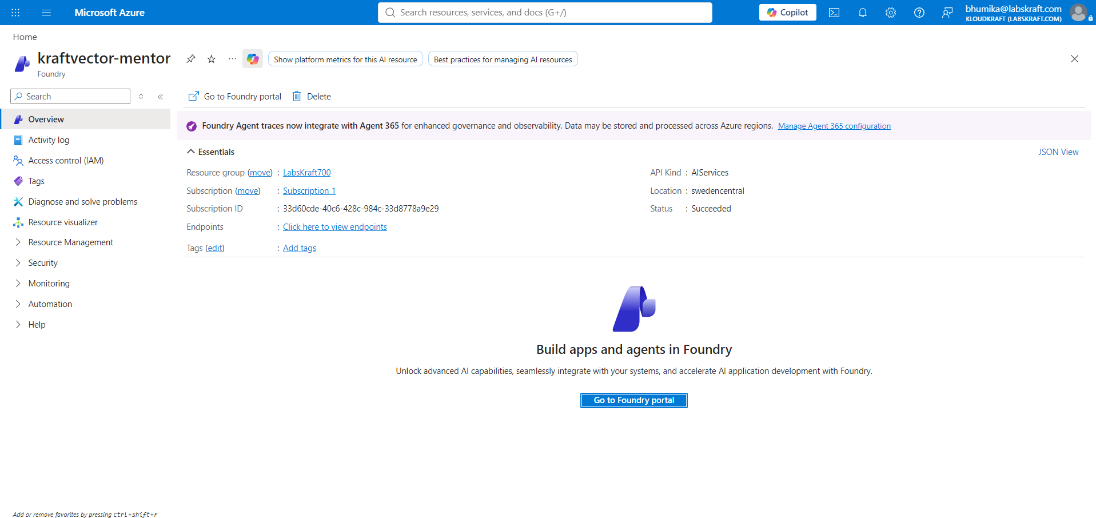
Expected result: The Foundry project opens successfully.

Step 2: Verify model availability
- Navigate to Build → Fine-tune.
- Start creating a fine-tuning job.
- Select gpt-4.1-mini, if available.
- Confirm that Supervised fine-tuning (SFT) is supported for your project and region.
- Verify that you have the required permissions and quota.
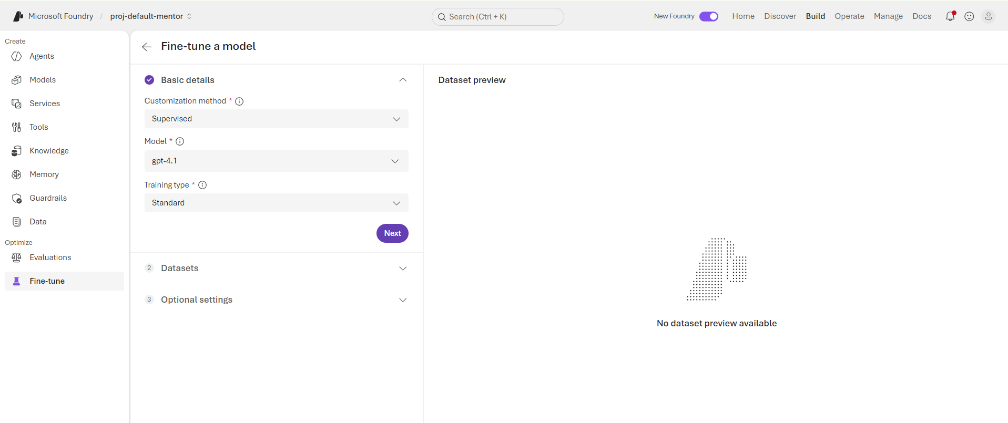
Expected result: GPT-4.1-mini and SFT are available for selection.

Step 3: Create the training dataset
- Open Visual Studio Code or a plain-text editor.
- Create a file named training_set.jsonl.
- Add the following examples, keeping each JSON object on a separate line.
- Save the file using the encoding required by Microsoft's fine-tuning documentation.
{"messages":[{"role":"system","content":"You are a concise IT help-desk assistant. Give safe, clear instructions."},{"role":"user","content":"How do I reset my password?"},{"role":"assistant","content":"Open your organization's password reset portal and follow the identity verification steps."}]}
{"messages":[{"role":"system","content":"You are a concise IT help-desk assistant. Give safe, clear instructions."},{"role":"user","content":"How do I request VPN access?"},{"role":"assistant","content":"Submit a VPN access request through your organization's approved IT service portal."}]}
{"messages":[{"role":"system","content":"You are a concise IT help-desk assistant. Give safe, clear instructions."},{"role":"user","content":"What should an IT ticket contain?"},{"role":"assistant","content":"Include the affected service, a clear description, the business impact, and any error message."}]}
{"messages":[{"role":"system","content":"You are a concise IT help-desk assistant. Give safe, clear instructions."},{"role":"user","content":"My laptop is running slowly. What should I do?"},{"role":"assistant","content":"Restart the laptop, close unnecessary applications, and check available disk space. Contact IT if the issue continues."}]}
{"messages":[{"role":"system","content":"You are a concise IT help-desk assistant. Give safe, clear instructions."},{"role":"user","content":"I cannot connect to Wi-Fi."},{"role":"assistant","content":"Check that Wi-Fi is enabled, reconnect to the approved network, and restart the device if needed."}]}
{"messages":[{"role":"system","content":"You are a concise IT help-desk assistant. Give safe, clear instructions."},{"role":"user","content":"I forgot my work username."},{"role":"assistant","content":"Check your organization's account portal or contact the IT help desk to verify your username."}]}
{"messages":[{"role":"system","content":"You are a concise IT help-desk assistant. Give safe, clear instructions."},{"role":"user","content":"How do I report a phishing email?"},{"role":"assistant","content":"Use your organization's approved phishing-reporting tool. Do not click links or open attachments in the suspicious email."}]}
{"messages":[{"role":"system","content":"You are a concise IT help-desk assistant. Give safe, clear instructions."},{"role":"user","content":"Can I share my password with a colleague?"},{"role":"assistant","content":"No. Never share your password. Use approved account delegation or access-request procedures instead."}]}
{"messages":[{"role":"system","content":"You are a concise IT help-desk assistant. Give safe, clear instructions."},{"role":"user","content":"An application keeps crashing."},{"role":"assistant","content":"Restart the application, record any error message, and contact IT if the problem persists."}]}
{"messages":[{"role":"system","content":"You are a concise IT help-desk assistant. Give safe, clear instructions."},{"role":"user","content":"I received an unexpected MFA approval request."},{"role":"assistant","content":"Deny the unexpected request and report it to your IT or security team immediately."}]}
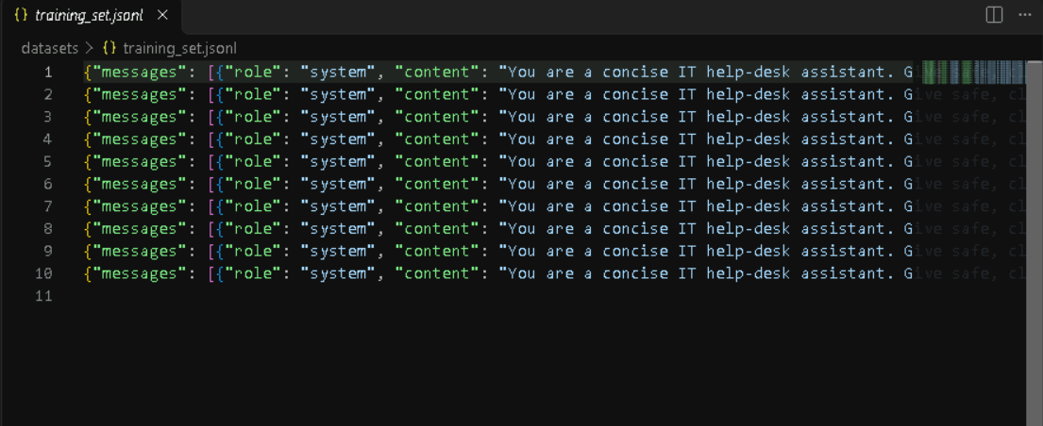
Expected result: The training dataset contains 10 valid conversational examples.

Step 4: Create the validation dataset
- Create a file named validation_set.jsonl.
- Add the following examples, one JSON object per line.
- Save the file separately from the training dataset.
{"messages":[{"role":"system","content":"You are a concise IT help-desk assistant. Give safe, clear instructions."},{"role":"user","content":"I think someone has accessed my account."},{"role":"assistant","content":"Report the suspected compromise to your security team immediately and follow your organization's account recovery process."}]}
{"messages":[{"role":"system","content":"You are a concise IT help-desk assistant. Give safe, clear instructions."},{"role":"user","content":"A coworker needs access to a restricted folder."},{"role":"assistant","content":"Ask the coworker to submit an access request through the approved process so the folder owner can authorize it."}]}
{"messages":[{"role":"system","content":"You are a concise IT help-desk assistant. Give safe, clear instructions."},{"role":"user","content":"What should I do with a suspicious attachment?"},{"role":"assistant","content":"Do not open it. Report the message using your organization's security procedure."}]}
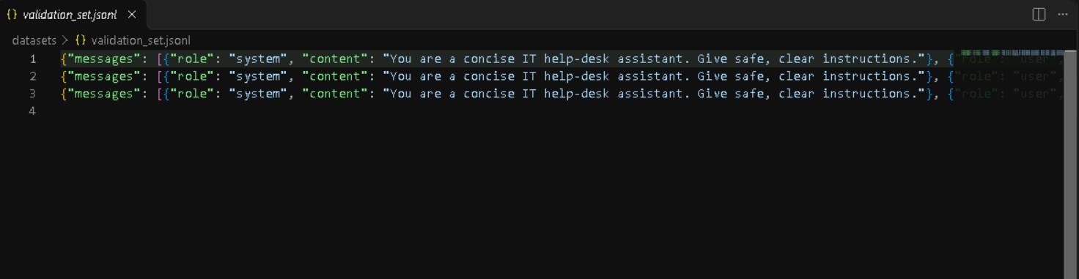
Expected result: The validation dataset contains three examples that differ from the training examples.

Step 5: Validate the datasets
- Check that both files contain valid JSONL.
- Ensure each line is a complete JSON object.
- Confirm that every example contains system, user, and assistant messages.
- Remove blank lines and any confidential information.
- Resolve formatting errors before uploading.
Expected result: Both datasets are ready for upload.

Step 6: Test the original model
- Open the Foundry playground or another approved inference interface.
- Select an existing GPT-4.1-mini deployment.
- Enter: I received an unexpected MFA approval request. What should I do?
- Record the response.
- Test two additional validation questions.
- Save the baseline responses for comparison.
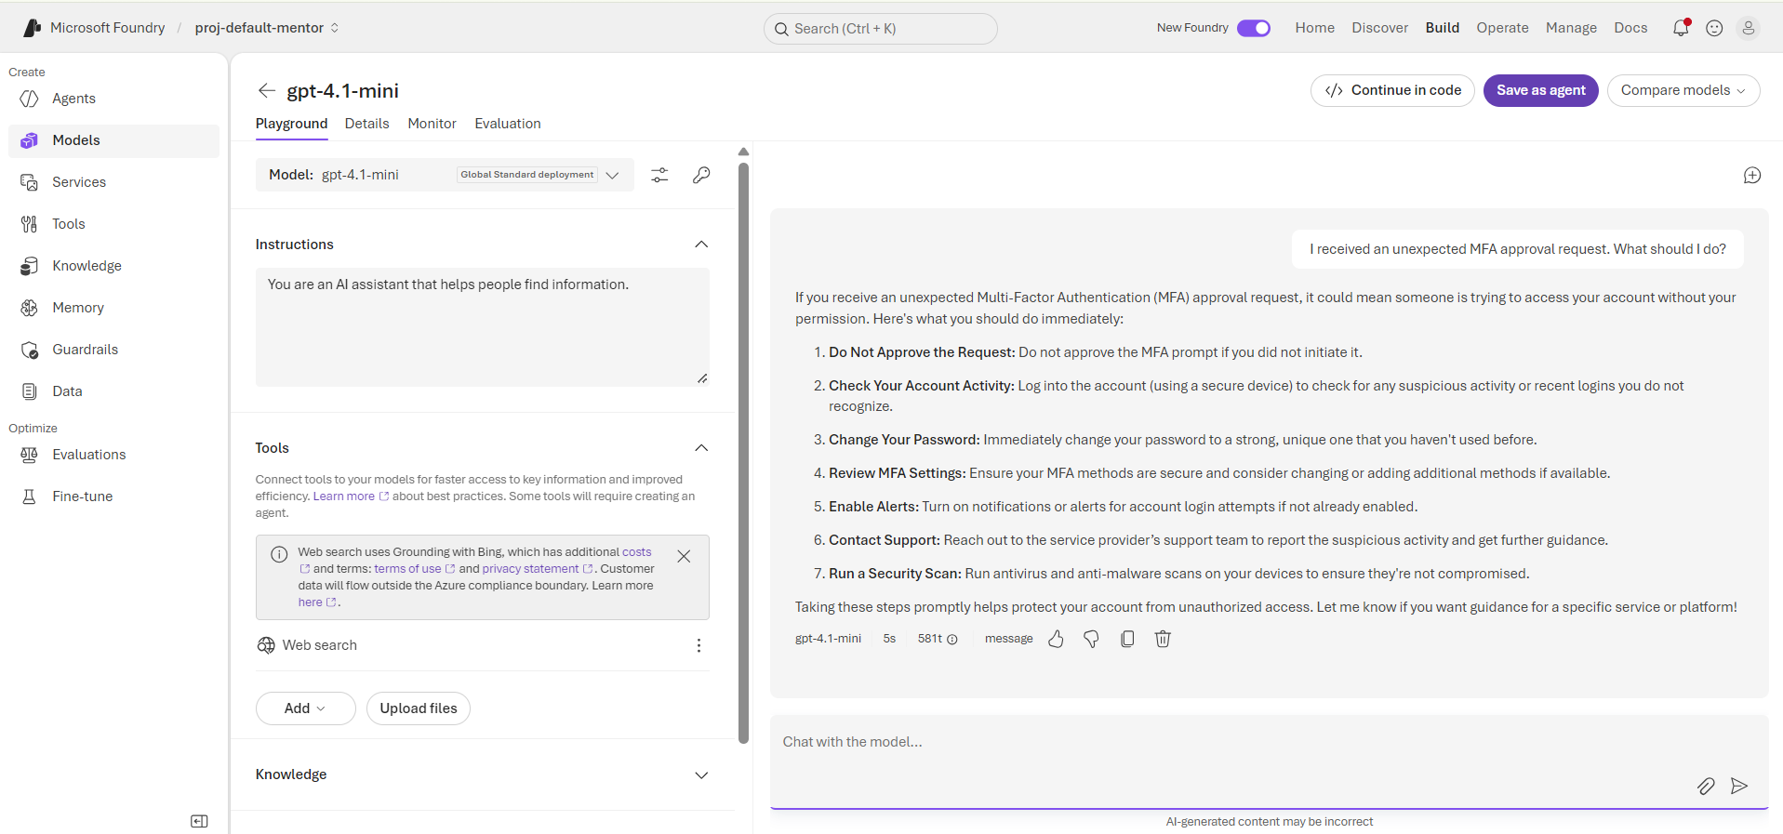
Expected result: Baseline responses are recorded.

Step 7: Create a fine-tuning job
- Navigate to Build → Fine-tune → Fine-tune.
- Select gpt-4.1-mini.
- Select Supervised fine-tuning (SFT).
- Choose a supported training configuration.
- Continue to the dataset configuration screen.
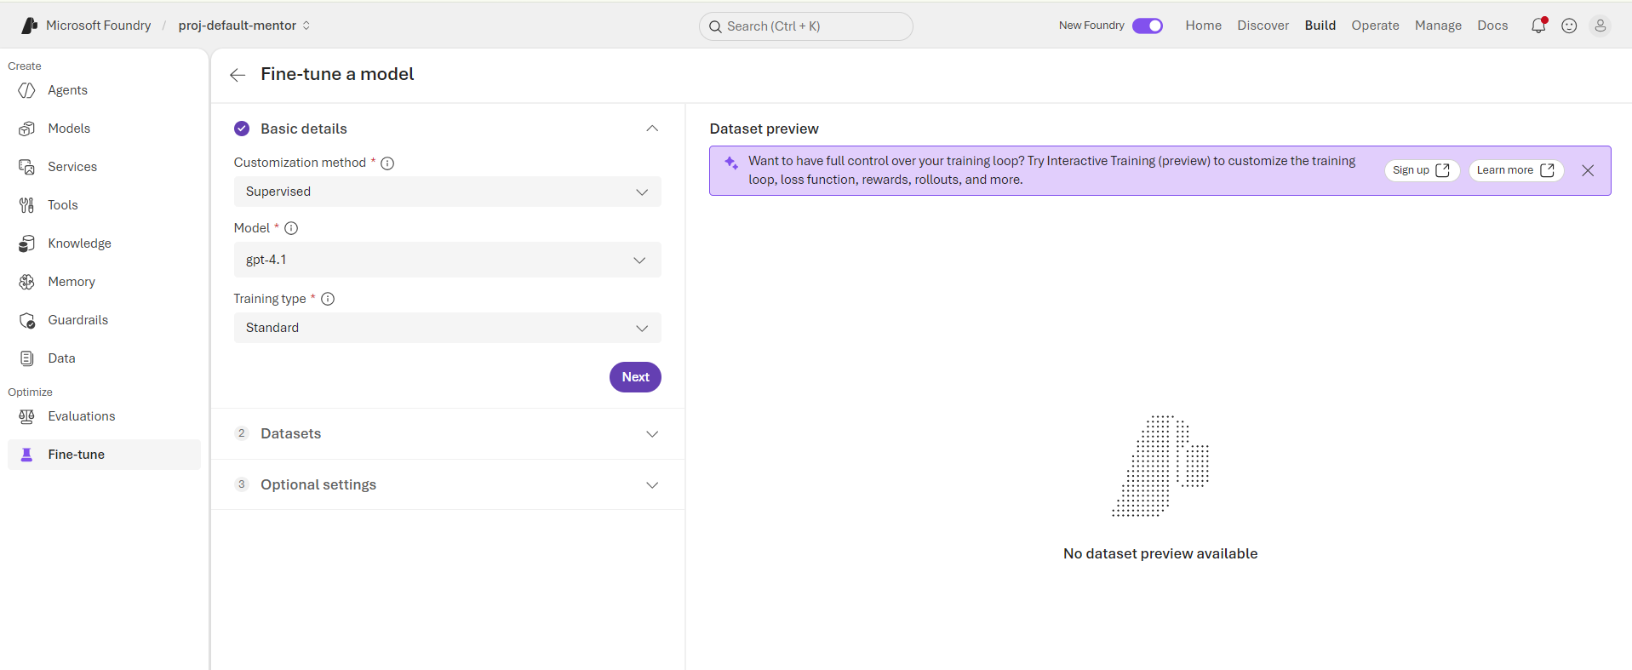
Expected result: The job configuration displays the selected model and training method.

Step 8: Upload the datasets
- Upload training_set.jsonl as the training dataset.
- Upload validation_set.jsonl as the validation dataset.
- Review the dataset previews.
- Resolve any validation errors.
- Confirm that each file is assigned to the correct field.
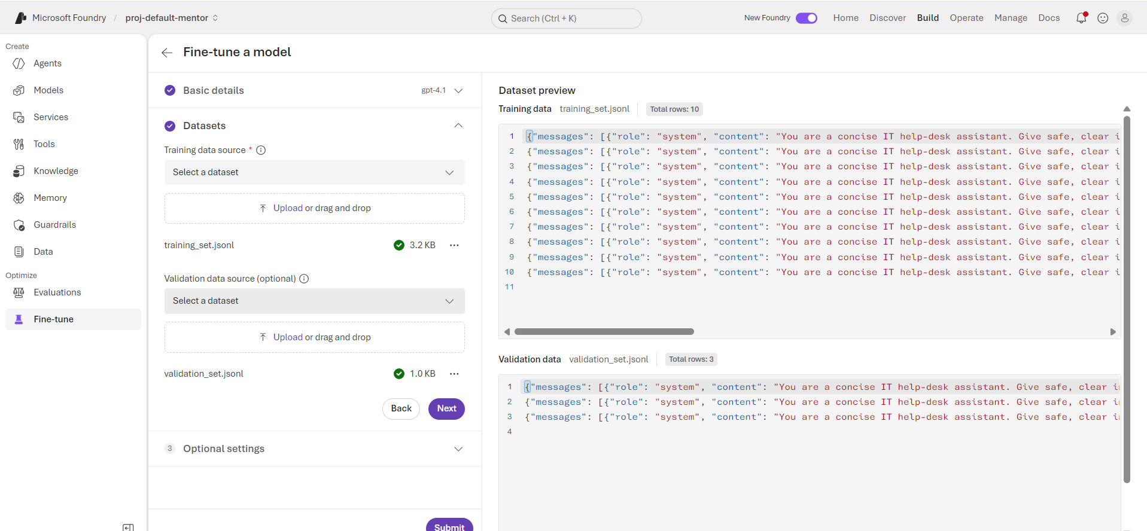
Expected result: Foundry accepts both datasets.

Step 9: Configure and submit the job
- Review the model and training method.
- Keep the default hyperparameters for the first run.
- Set a job name or model suffix if the portal offers that option.
- Review the estimated cost and available configuration.
- Submit the fine-tuning job.
- Record the job ID.
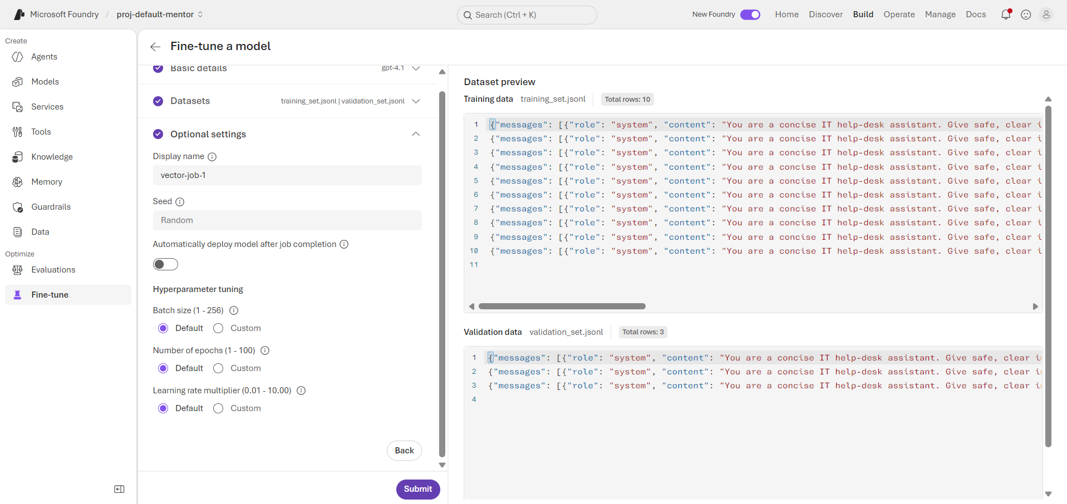
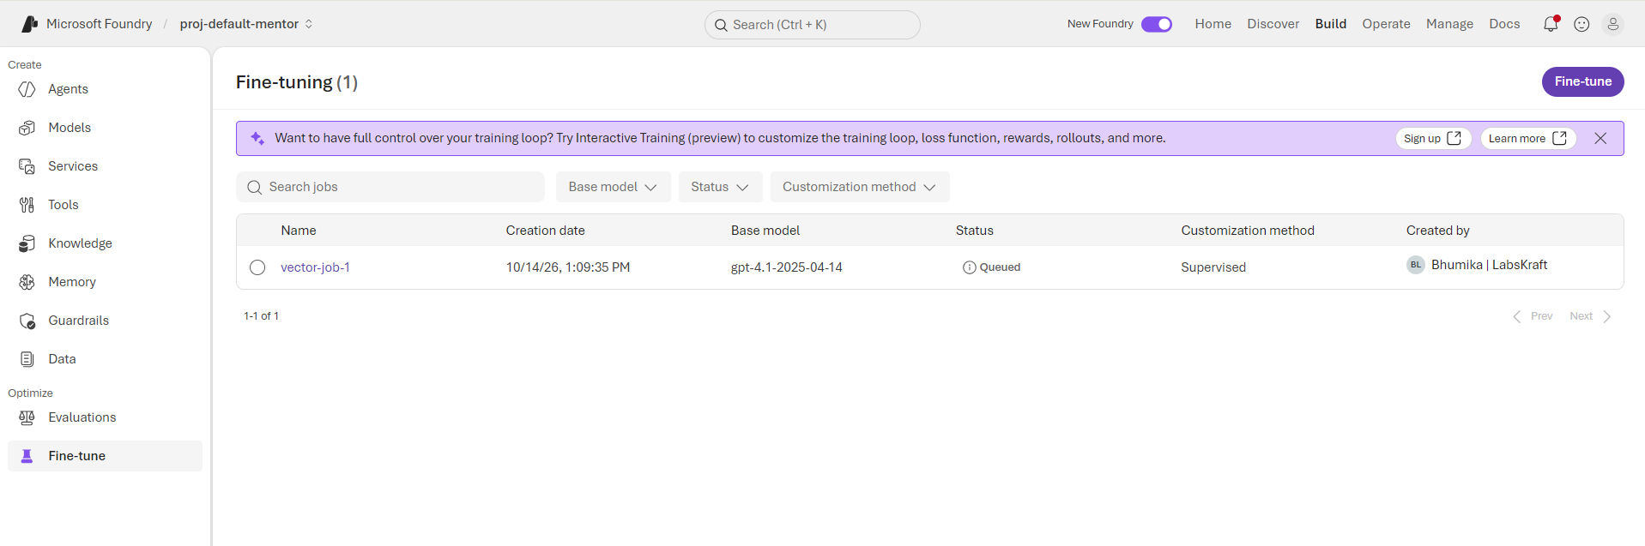
Expected result: The job is created and a job ID is available.

Step 10: Monitor the fine-tuning job
- Open the submitted job.
- Review its current status.
- Monitor the job until it reaches a final state.
- Review the available training and validation metrics.
- If the job fails, inspect the error details and resolve the issue before retrying
Note : Fine tune job might take long time to be successful or throw error.
Expected result: The job reaches succeeded.
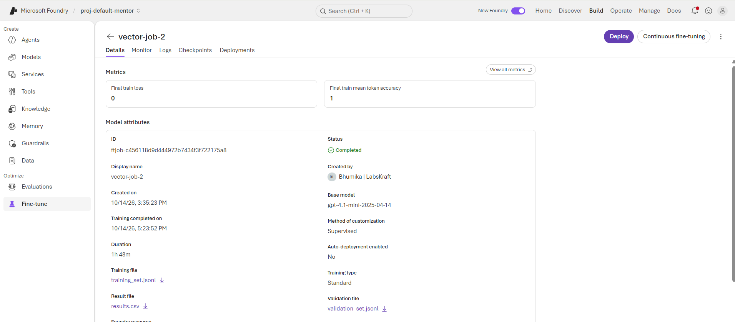

Step 11: Deploy the fine-tuned model
- Open the successful fine-tuning job or resulting model entry.
- Select the deployment action, if available.
- Enter a deployment name, such as lab11-helpdesk-ft.
- Select a supported deployment configuration.
- Review costs and permissions.
- Create the deployment and wait until it is ready.
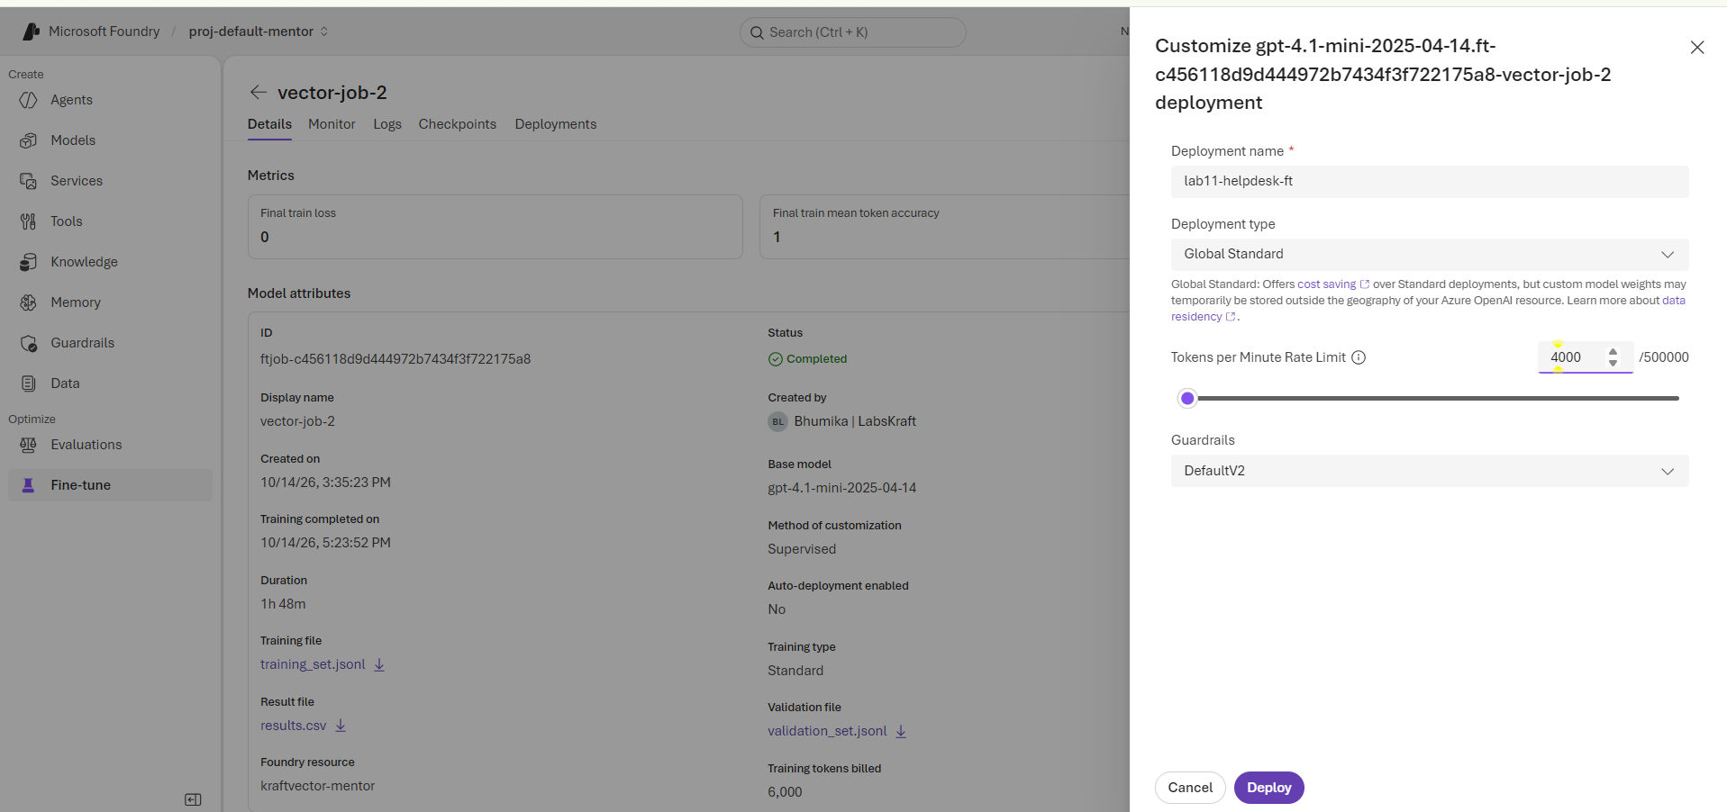
Expected result: The fine-tuned model is deployed and ready for inference, if deployment is in scope.

Step 12: Test the fine-tuned model
- Open the fine-tuned model in an approved inference interface.
- Submit the same prompts used to test the original model.
- Record the responses.
- Compare correctness, clarity, consistency, and safety.
Test prompts:
- I received an unexpected MFA approval request.
- Can I share my password with a colleague?
- I think someone has accessed my account.
- A coworker needs access to a restricted folder.
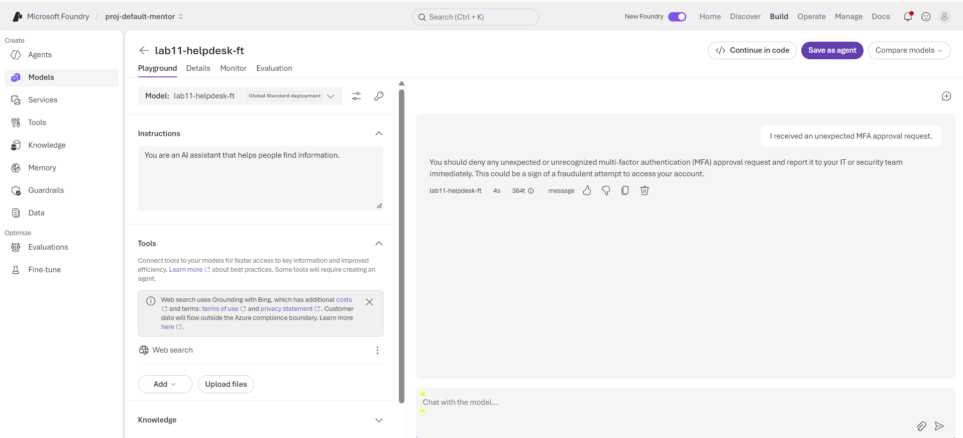
Expected result: Original and fine-tuned model responses are compared using the same prompts.

Step 13: Perform Responsible AI checks
- Review the datasets for sensitive or confidential information.
- Check responses to password-sharing and suspicious-MFA questions.
- Identify unsafe or misleading recommendations.
- Review available evaluation results.
- Document limitations and corrective actions.
Expected result: Basic safety findings are documented.

Step 14: Save validation evidence
- Capture the Foundry project and model selection.
- Capture successful dataset uploads.
- Capture the fine-tuning job ID and final status.
- Capture available training metrics.
- Capture deployment status if deployment was completed.
- Record the model comparison and safety findings.
- Ensure screenshots do not expose credentials.
Expected result: Evidence is available for trainer review.

Step 15: Clean up
- Identify resources created specifically for this lab.
- Confirm that assessment is complete.
- Obtain approval before deleting resources in a shared environment.
- Remove only approved lab-created resources.
- Retain required evidence and confirm that unnecessary billable deployments are no longer active.
Expected result: Lab cleanup is completed safely.

